**High Level Design Document Detailing The Design Elements**

**And Flow Of Events**

**Creation of Site Collection**

* Created a new Site Collection for Sales Portal “MFRP”.

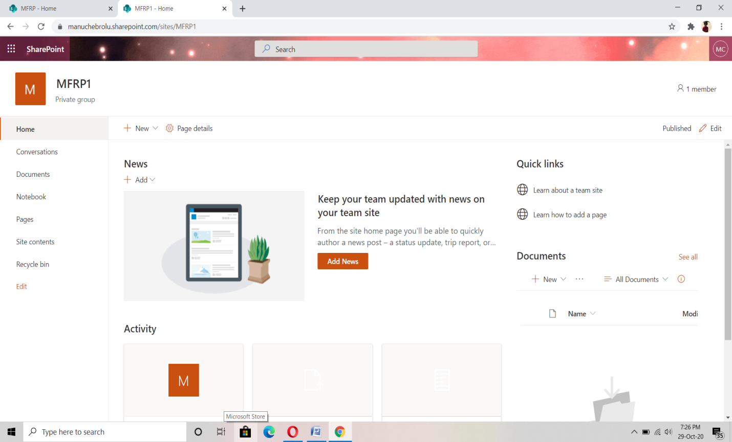

* **Creation of SharePoint Lists**

Three SharePoint lists have been created namely:

1. Customers,
2. Products,
3. Orders

**(i) Customers List**

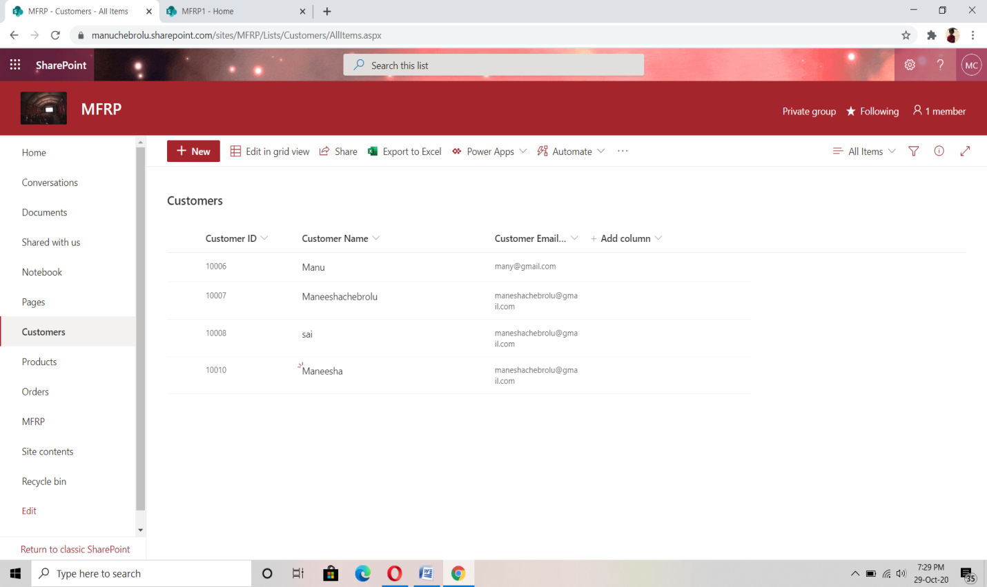

**(ii) Products List**

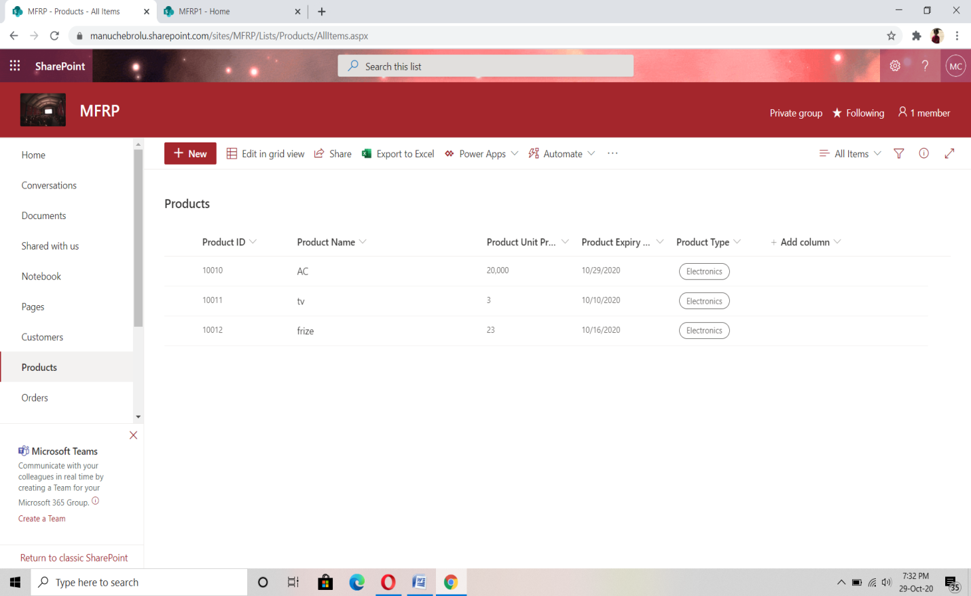

**(iii) Orders List**

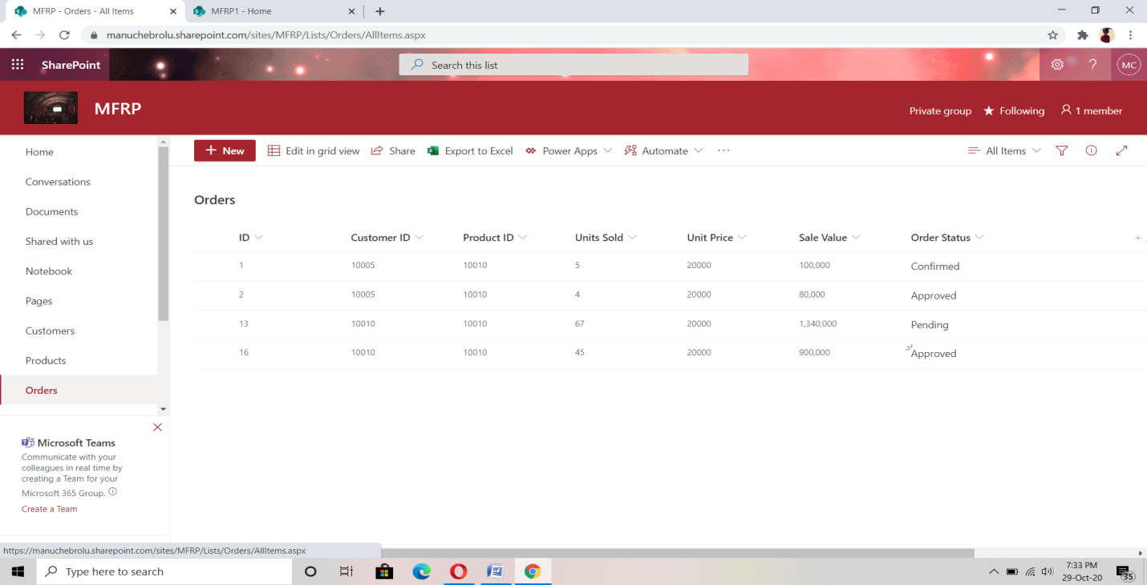

1. **Adding validation of list fields using Pre Save Action**

**(i) Customers list**

* Since Customer ID is auto generated, adding anything to this textbox with show an alert.

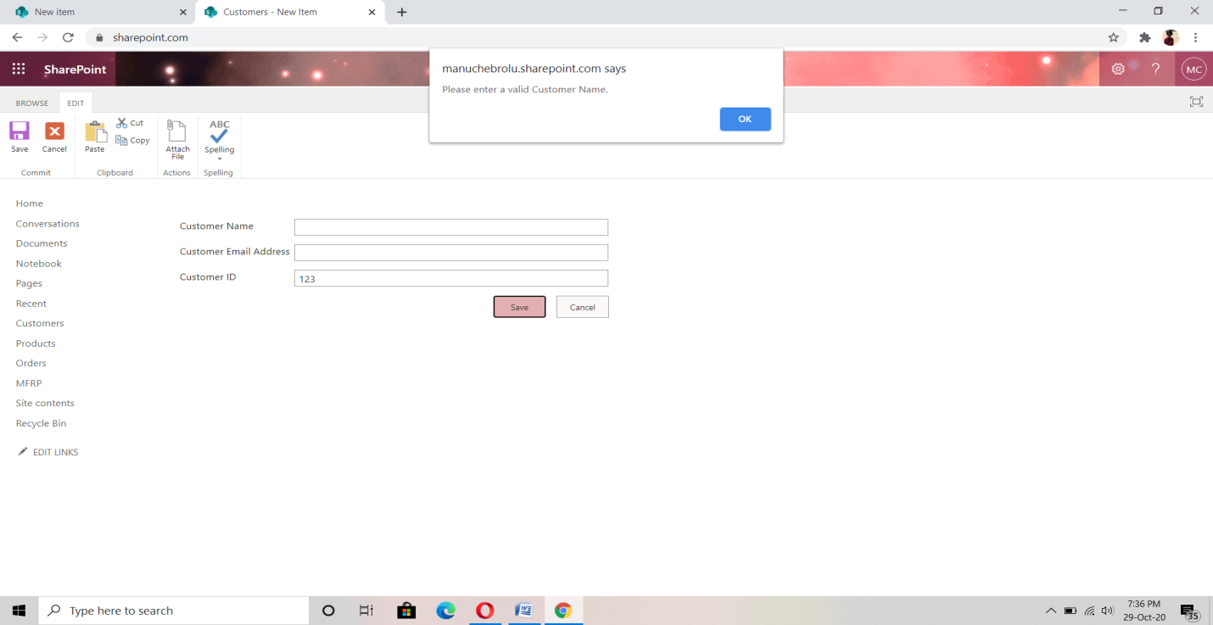

* Customer name cannot contain numbers

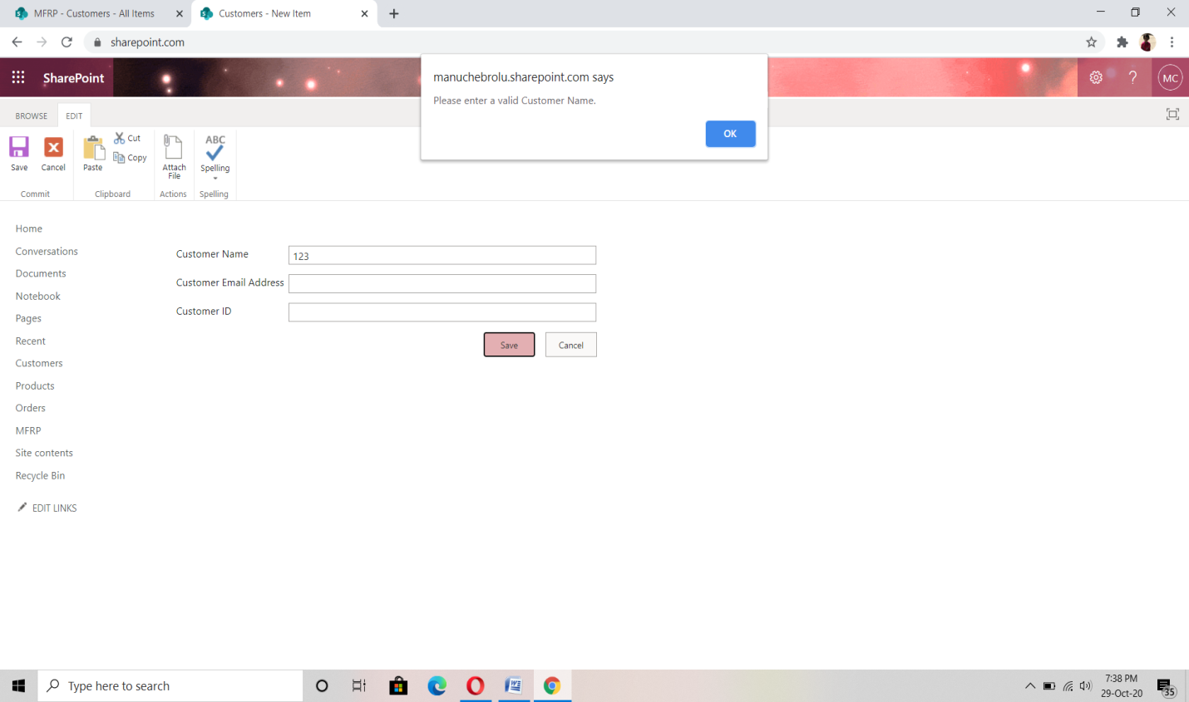

* Customer Email should be of valid format.

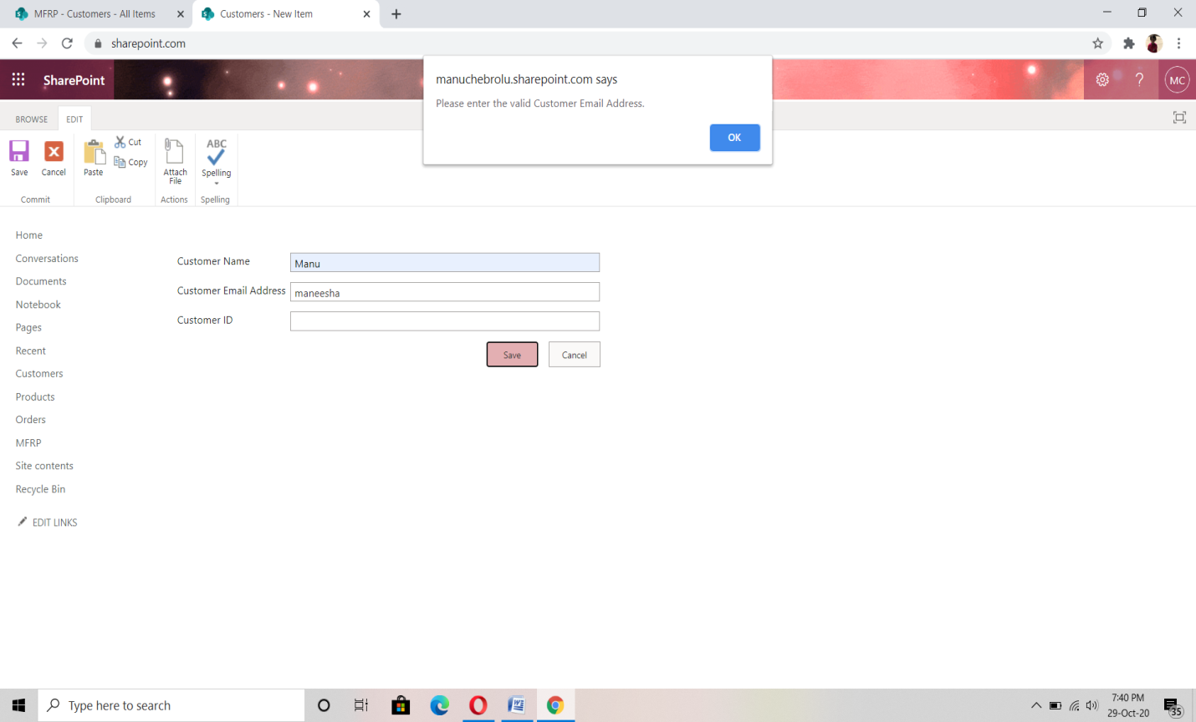

**(ii) Products List**

* Since Product ID is autogenerated, adding anything to this textbox with show an alert.

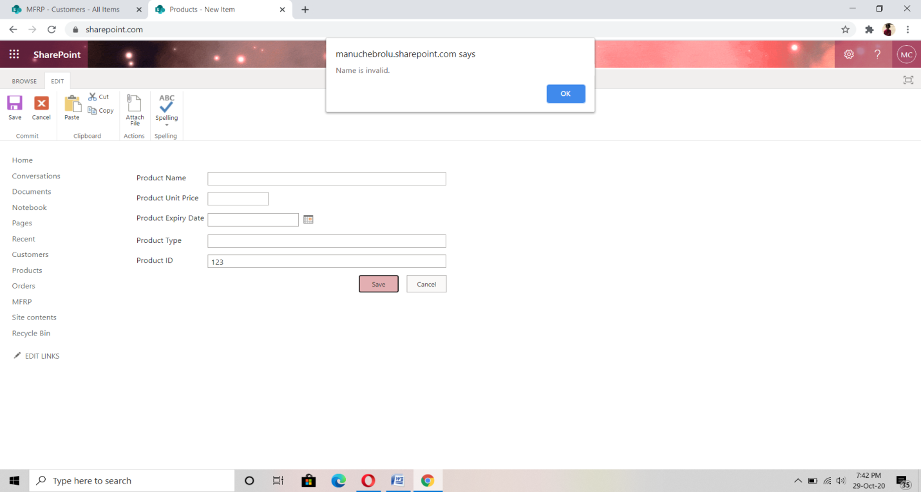

* Product name cannot contain numbers.

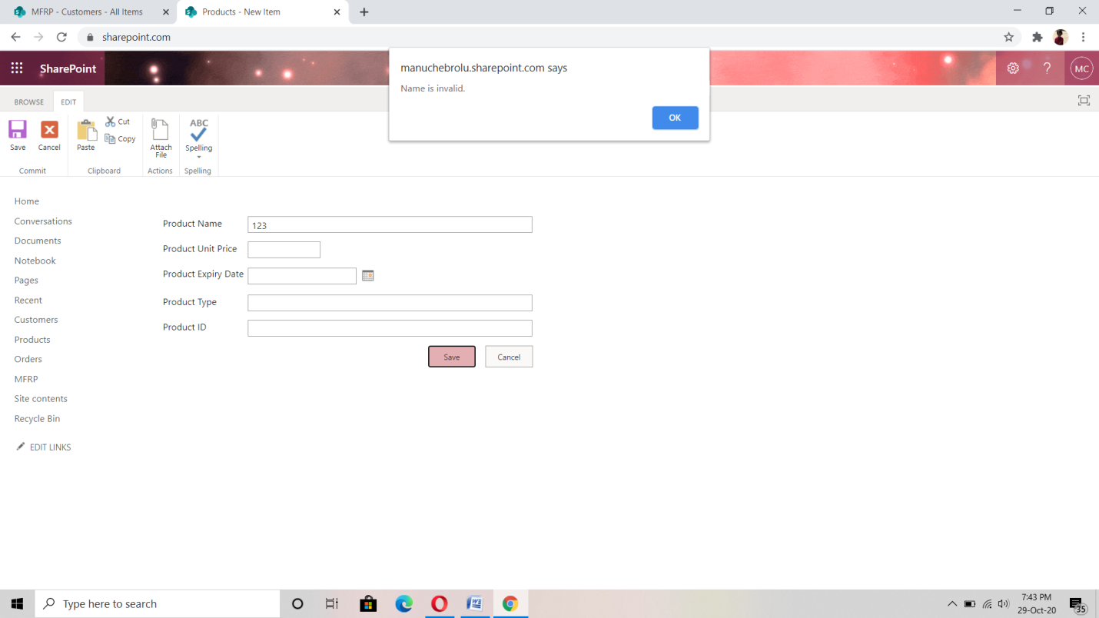

* Price cannot contain alphabets.

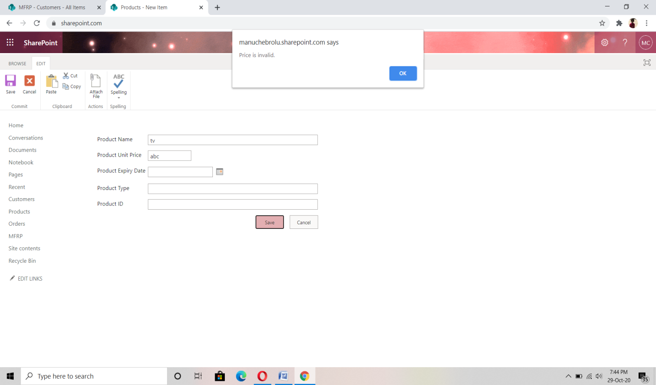

* Date field cannot be empty.

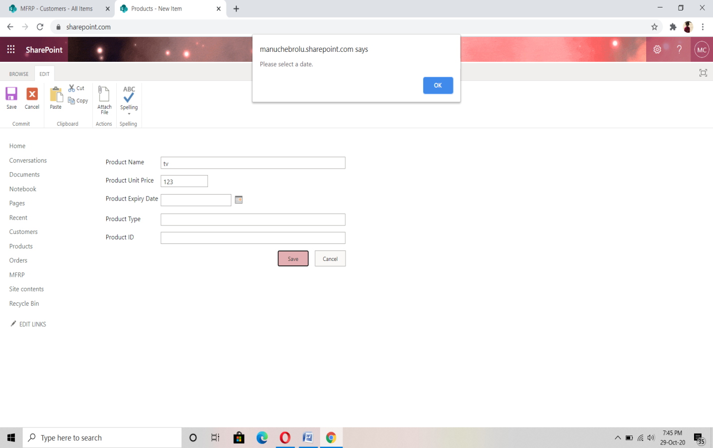

**2. Building SPFx Webpart**

(i) Created a new Webpart with name “sales-order” with React js UI.

(ii) Added UI fields for Order Entries.

(iii) Added Buttons for Add, Update, Delete and Reset functionalities.

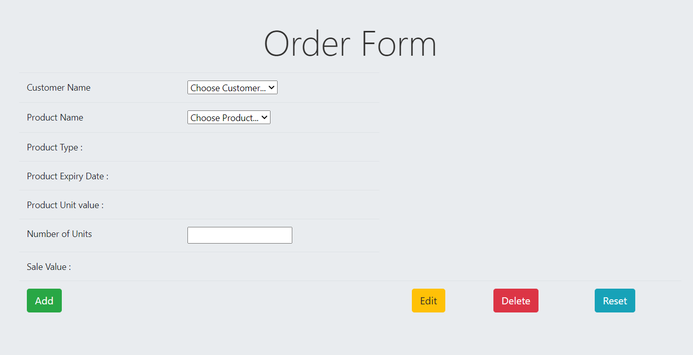

* **Validation in SPFx Webpart**

If we are not Selecting anything gives an alert message for ADD function.

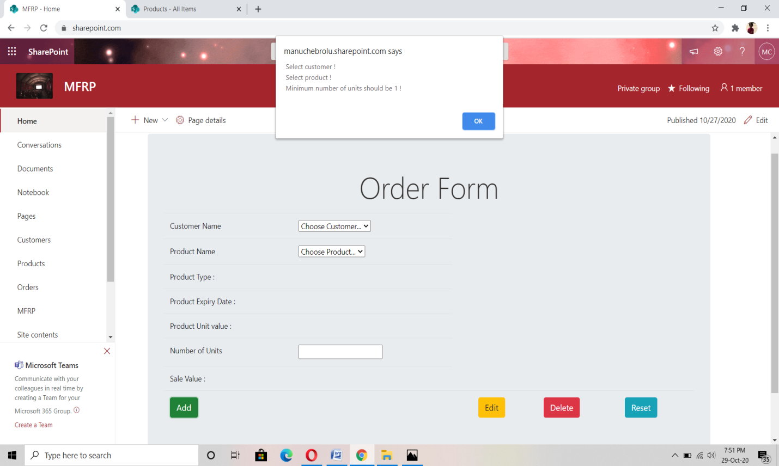

For edit function , delete function must select order ID.

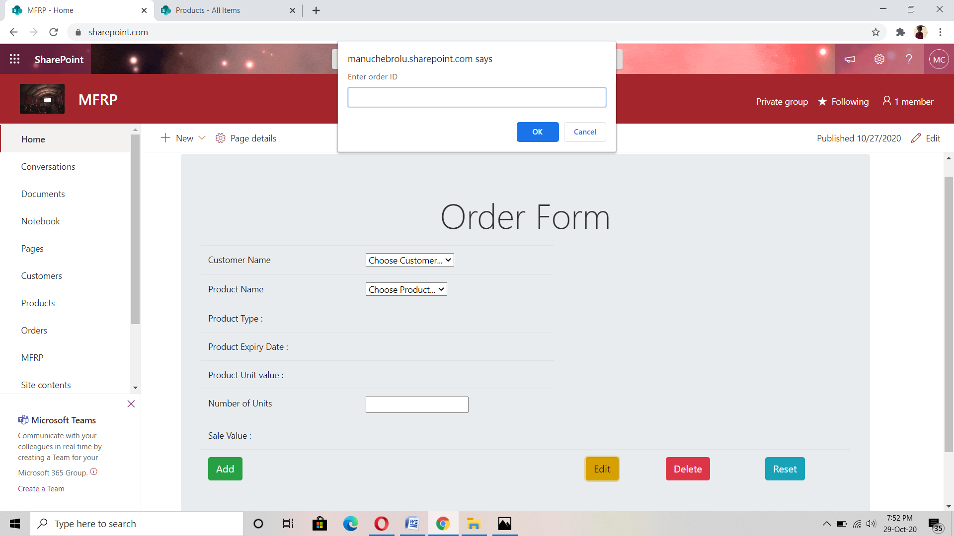

* **Add functionality**

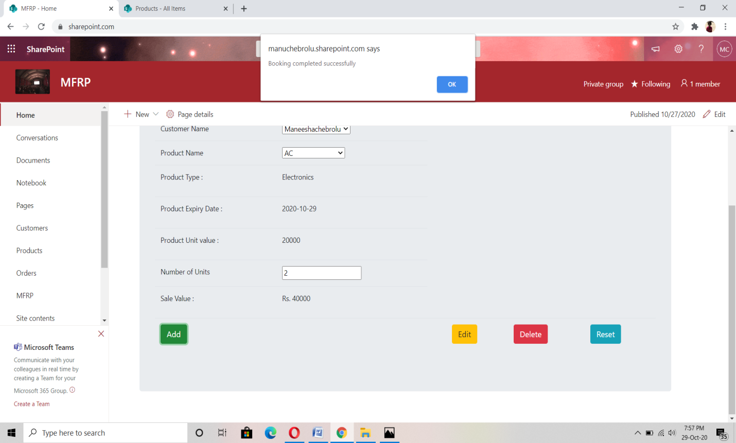

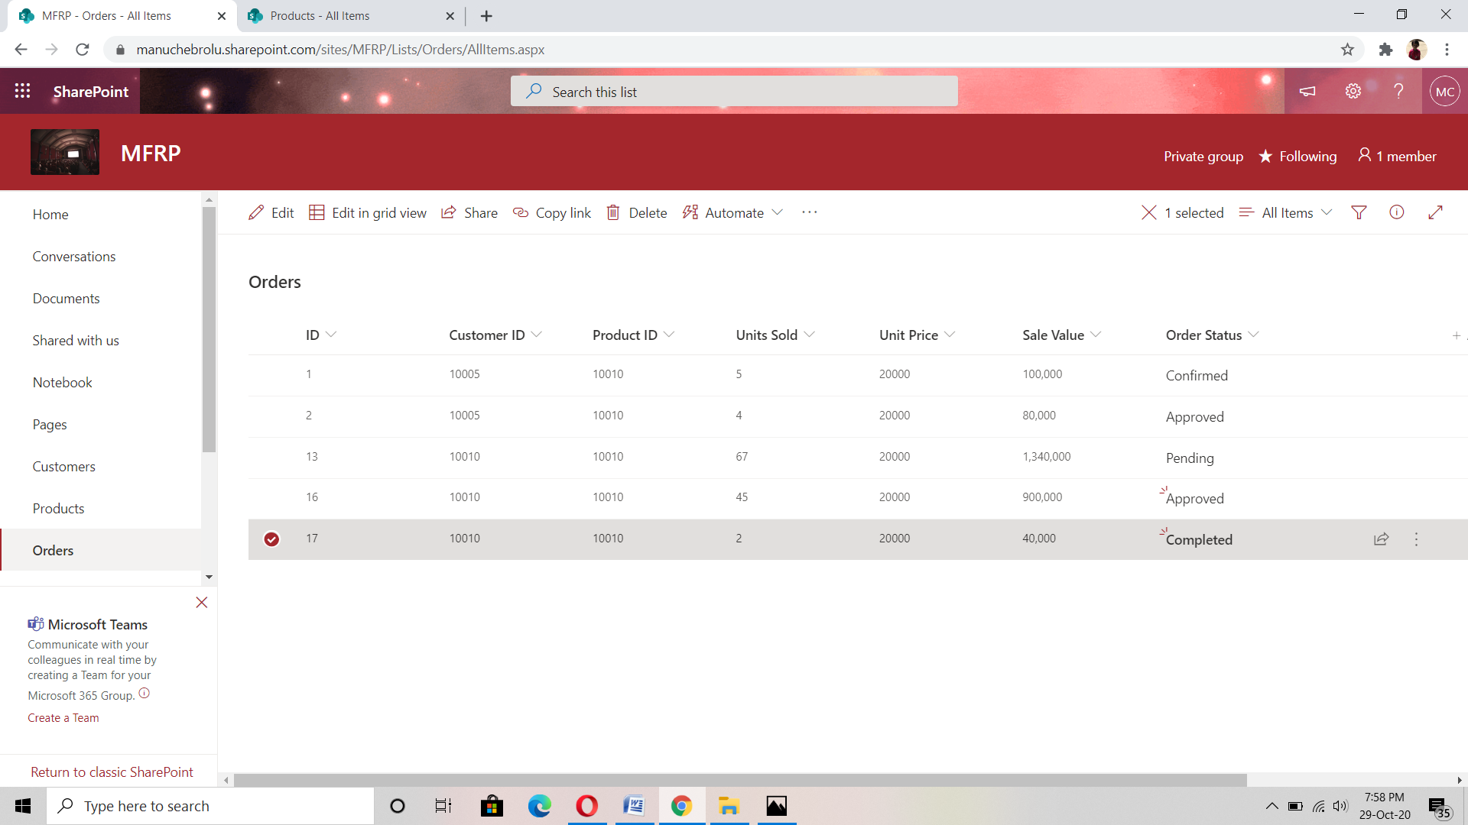

* **Update Functionality**

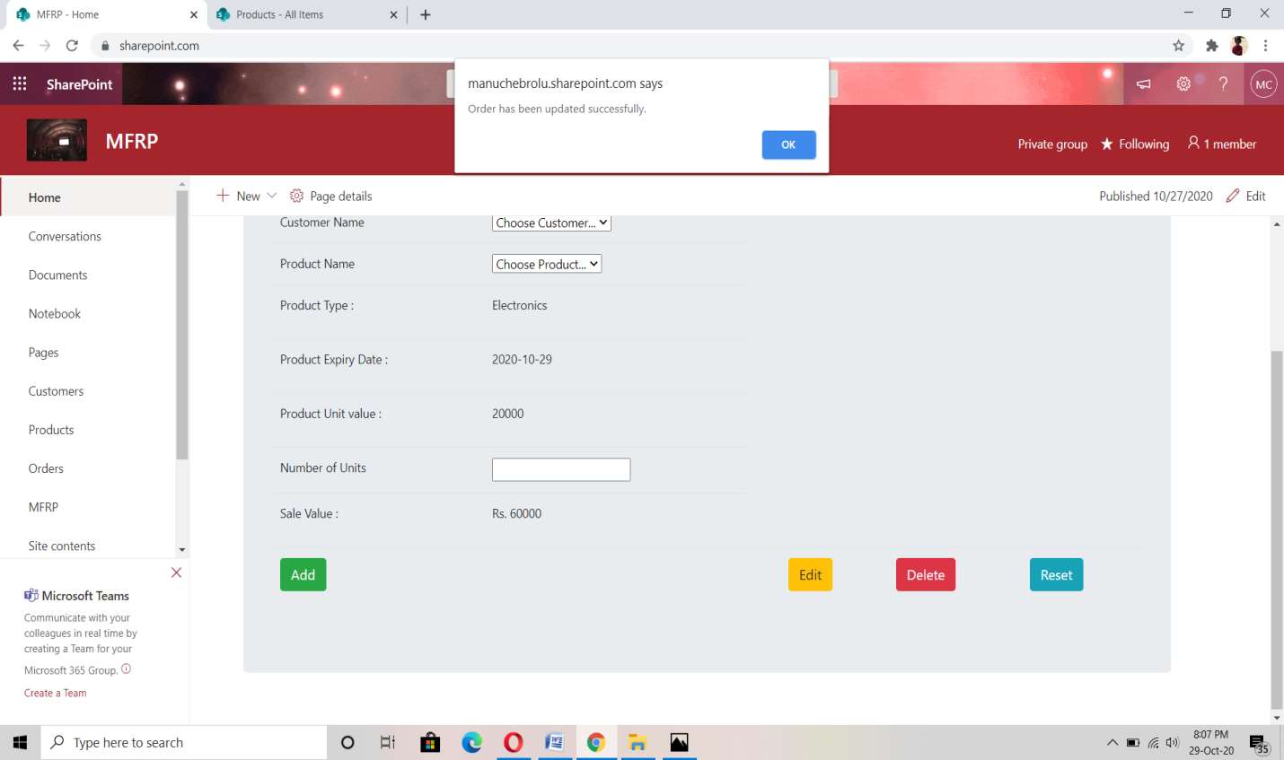

* **Delete Functionality**

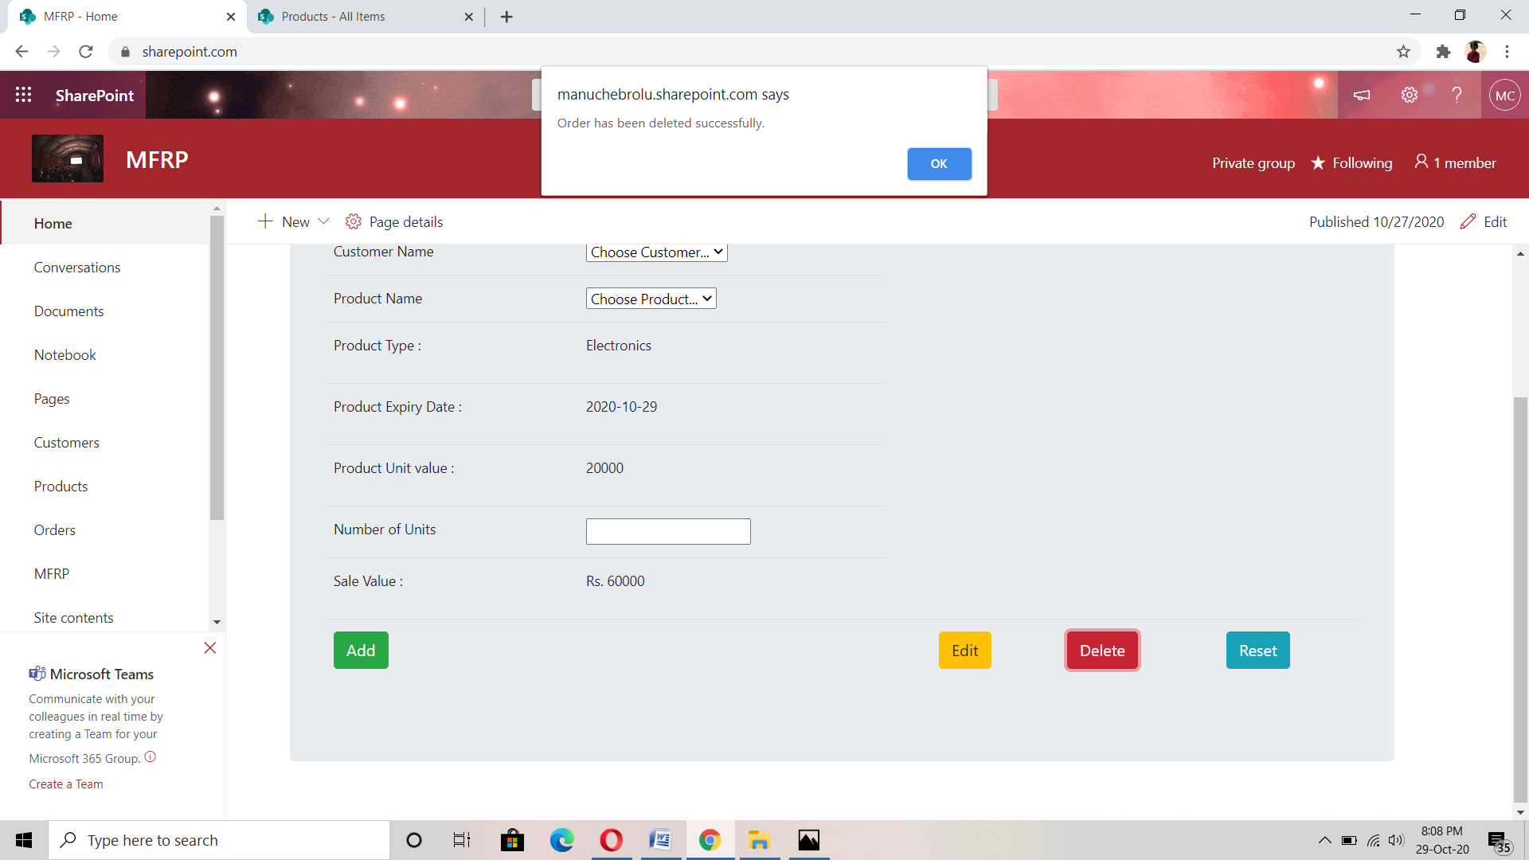

* **Reset functionality**

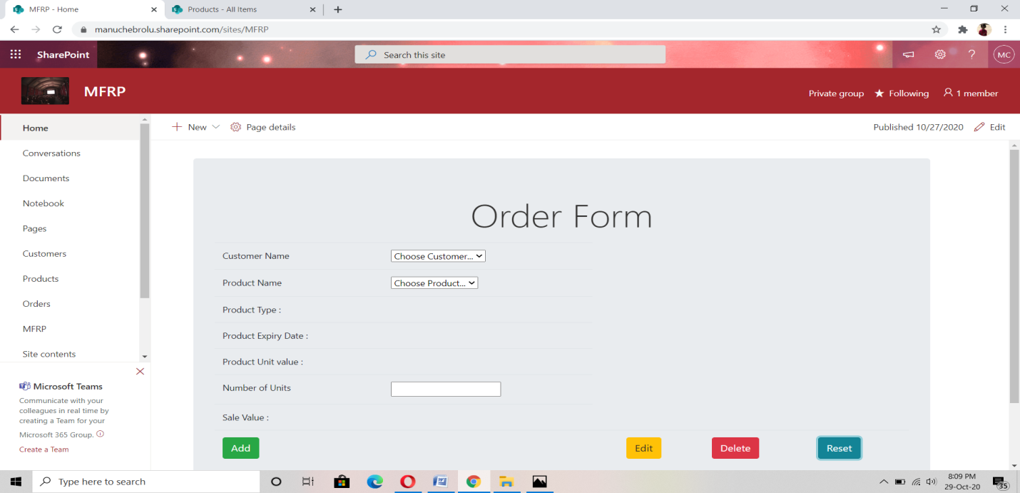

**3.Power Automate: sending mails using flows**

* **When an item is created in the orders list**
* If sale value > 100000, it sends an approval mail to sales manager.

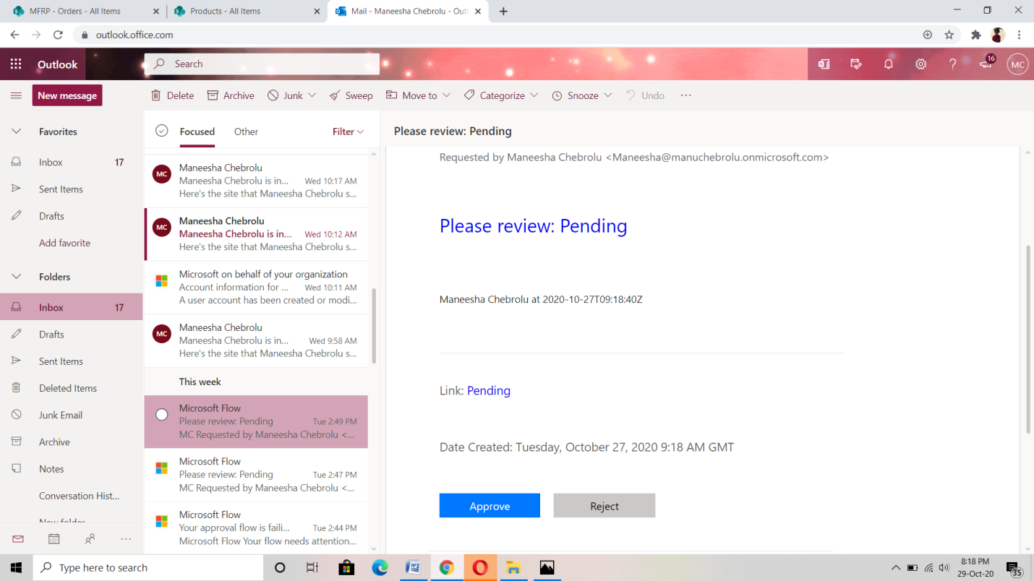

* After the sales manager approves it, order status gets updated to Approved

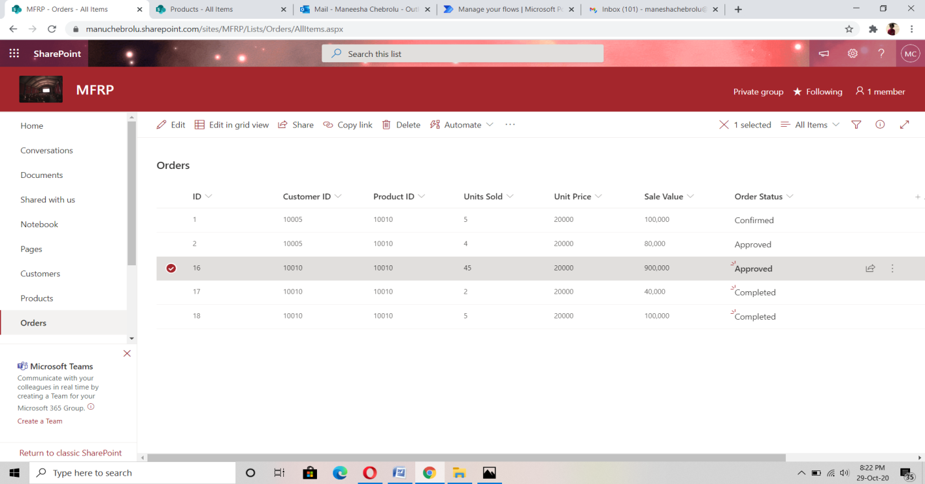

* Else if sales manager rejects the request, order status gets updated to

rejected.

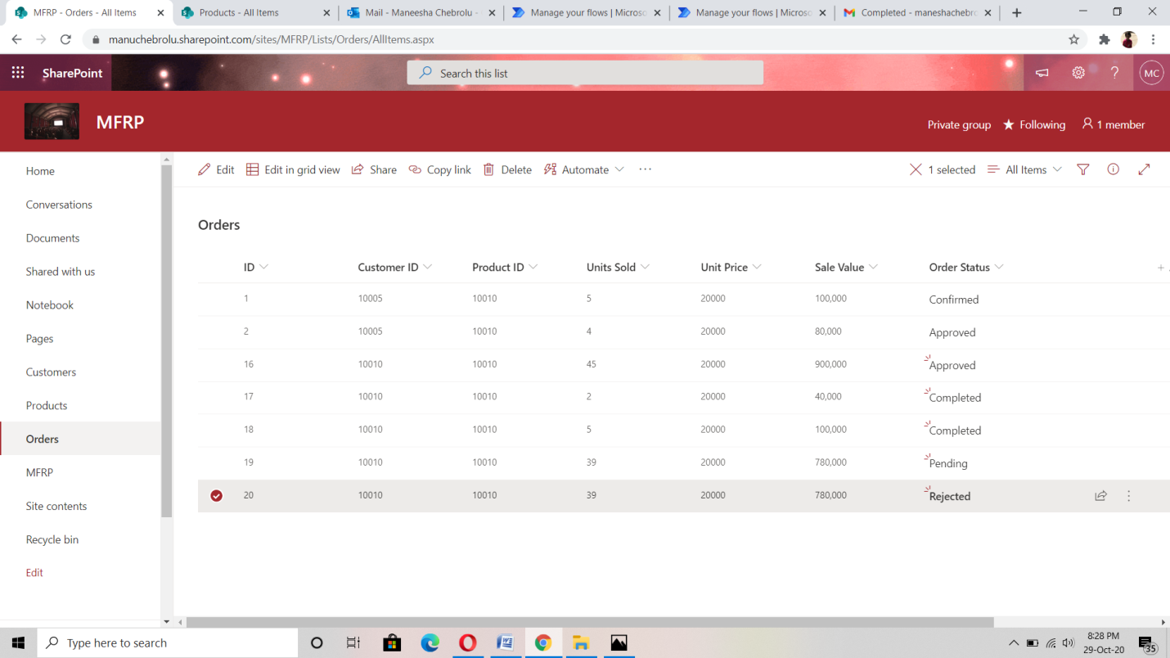

* If Sale value < 100000, customer receives an invoice mail and order status gets updated to completed

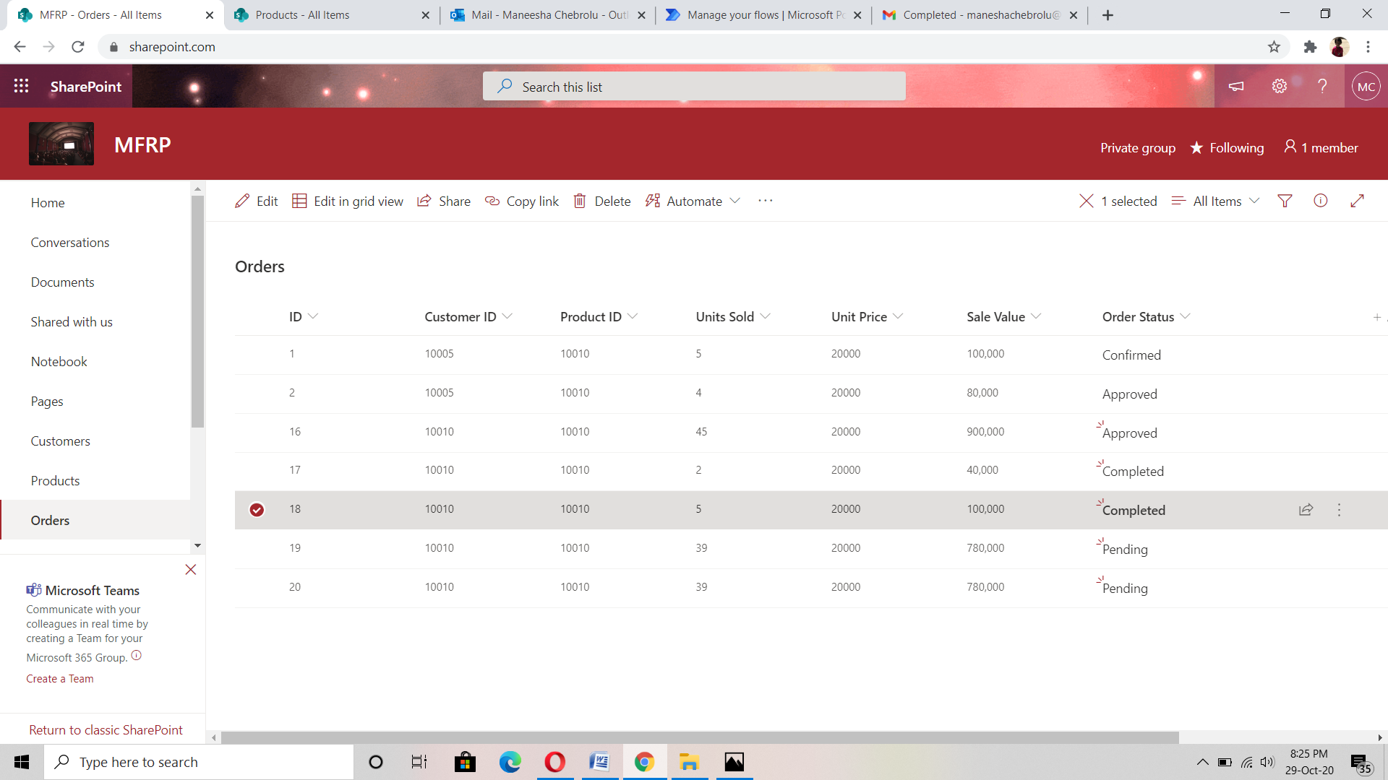

**4. Security Groups**

* Created two security groups: Administrator and Sales Manager.
* Administrator: able to add/edit/delete records in all the lists.
* Sales Manager: have read access to customer and Product, Contribution access to Orders list.

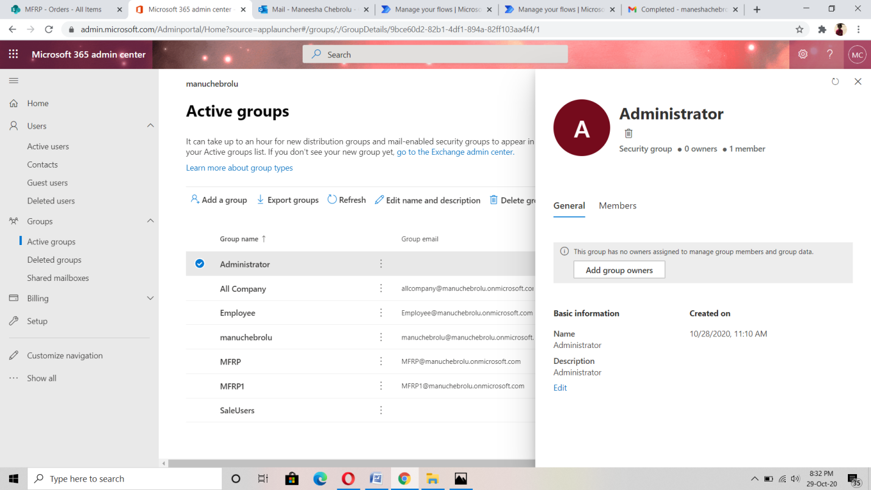

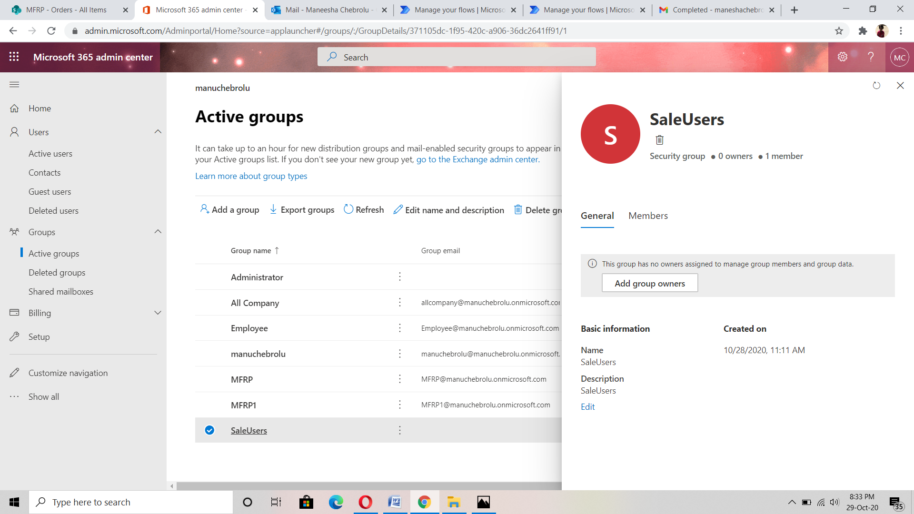

* Administrator group have full control to perform edit and delete functions.

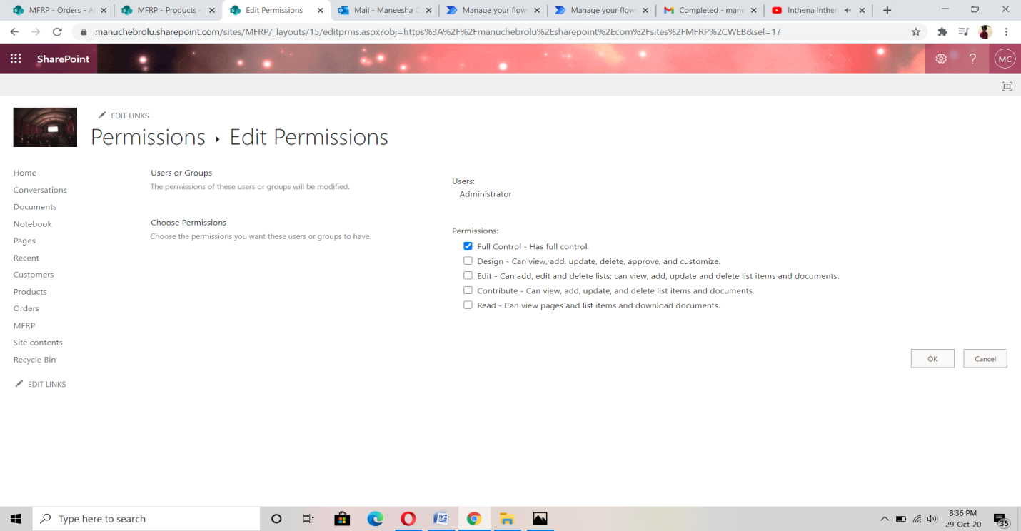

* Sale User have contribute permission does not have permissions to perform those functionalities.

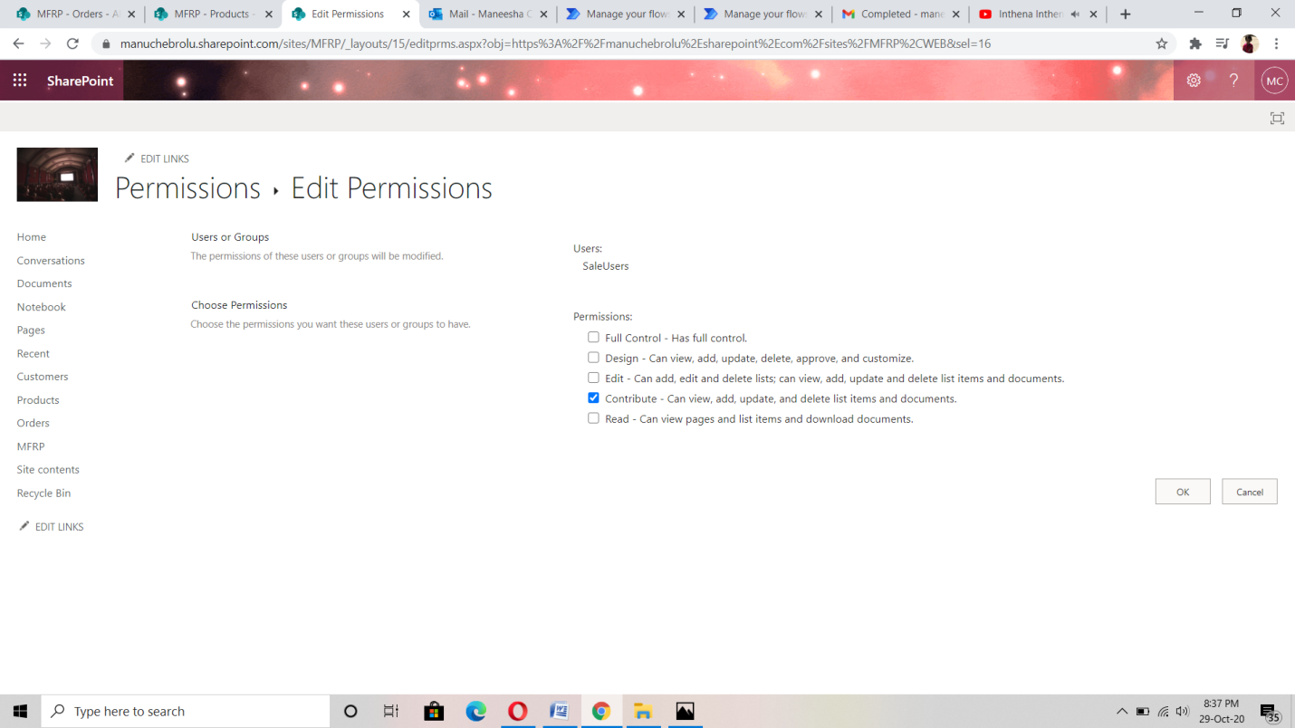

**5. Report Generation**

* Report generation is triggered using Microsoft flows
* The flow is scheduled for once in a month.
* Flows checks for the condition: If order status is “Approved or Completed”
* It creates a report in excel format.

